Information For Mayan Palaces:Gold Crown, Five Star Resorts

Mayan Riviera (East Coast between Cozumel and Cancun) *(Been there)
Mexico Riviera:
Nuevo Vallarta: West Coast *(Been there)
Puerto Vallarta: West Coast (in heart of city,popular, smaller resort)
Puerto Penasco: 4 hour drive south from Phoenix (West Coast of Mexico) (newest resort- no airport nearby, so they are building their own international one)
Alcapulco (West Coast)
http://www.mayanpalace.com/
hold down the control key to connect or copy and paste into explorer

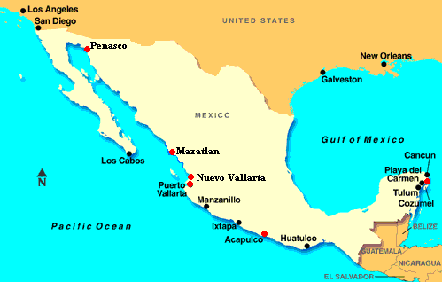

Rental Price: 3 Choices
$ 1969 2 bedroom; 2 Bath Master Suite Teacher Price: $1569
or
$1700 one bedroom suite( Sleeps 4, full kitchen) Teacher Price: 1300
or
$400 master room (sleeps 2-4- no kitchen) Teacher Price $300

Six month booking before you travel assures good choice of dates.
Not available for Christmas Week or Easter Week.

For Lots of photos hit control and the link
http://www.sfx-resorts.com/resortreviews/mayanphotos.htm

http://www.sfx-resorts.com/resortReviews/grandmayanacapulco.htm

http://www.sfx-resorts.com/ResortReviews/MayaRiviera.htm

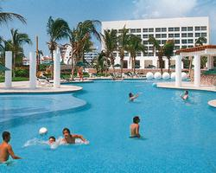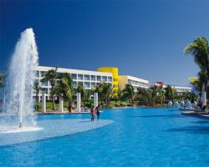

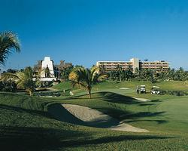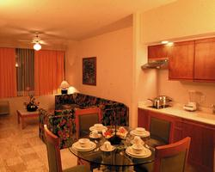

Gold Crown Resort 5 star- Sleeps 6 -8; Restaurants on site; Markets; Oceans; internet bar;

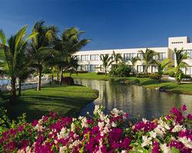

More information on the next page!

Also can offer (lock outs may not able available, still sleeps6- 8 ) rental price in other locations: (has a $50 exchange fee, per week).
These all appear to be Gold Crown or Resorts of International Distinction: RCI’s highest rating. Will get you the names if interested.
See Attachment for Condo Names.

Scottsdale, AZ Redmond, OR
Sedona, AZ Portownsend, WA
Payson, AZ Ketchum, Sun Valley
Estes Park, CO Angel Fire, NM
Steamboat Springs, CO Atlantic City, NJ
Orlando, FL South Padre Island
St. Petersburg, FL Branson, MO
Ramona, CA Abaco Island, Bahamas
Palm Springs, CA Freeport, Bahamas
Kihei, Hawaii San Jose, Costa Rica
Lahina, Maui Quepos, Costa Rica
Kihei, Hawaii ST. Maarten, Netherlands
Princeville, Kahuai Aruba Dutch West Indies
Las Vegas, NV Cabo San Lucas, Mexico
Lake Tahoe, NV Rosarito, Mexico
Daytona, Fl Christmas week-Book now
Waters Edge Week 25 unit 612 (usually the last week in June) (not 2005 already booked- reserve by January)

Call Pam Benn: 245-0312 or kiwood@reekielum.com

Mazatlan

